**Observation**

Inspection was undertaken at the subject property to which the following was noted:

## Overall Observations

1. The subject building is essentially a pseudo portal framed shed which has been predominantly enclosed along the perimeters with the exception of southern side providing access for storage of machineries and parts.
2. The building in general is in dilapidated and decrepit state with widespread deteriorated building elements and members including but not limited to steel post and beams, timber roof purlins and in particular corroded roof sheets about the western side of the building.
3. The eastern part of the building roof has been cladded with asbestos corrugated roof sheeting where a number of roof sheets are missing along with flashing and ridge capping.
4. The aforementioned building also accommodates an office building on the eastern end of the building which has been covered under the same building envelope with asbestos roof sheeting; however, the office wall claddings and elevations are in a better maintained condition.
5. The following diagram has been provided in clarifying the locations and extent of roof cladding types for reporting and referencing purposes:

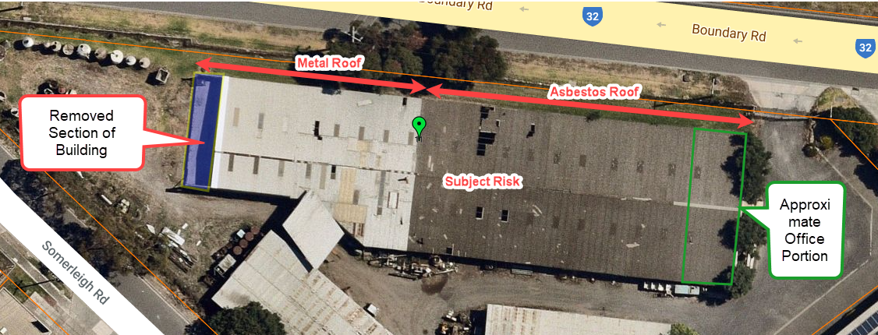

Figure 2 – Site View with Reference to Extent of Roof Cladding Types

## Roof Cladding

### Metal Roof Portion and Cladding

1. From our drone survey, sections of roof metal cladding including ridge capping are missing with one piece of detached roof sheet was still resting over the roof. **Images 2 & 3**
2. We also noted a section of polycarbonate roof sheet was missing.
3. The remainder of ridge capping is in corroded state with some parts are detached from the roof sheets.
4. Evidence of poorly installed roof sheet patch repairs using varying length and colour of sheets was noted that have been carried previously in an attempt to maintain the building envelope weatherproofing. **Image 4**
5. From internal inspection within the shed, we noted significant corrosion of the metal roof sheets generally along the laps and joints where in area has effectively resulted in loss of metal material. **Images 5 to 9**
6. Along the aforementioned corroded and missing roof sheets, we noted deflection and deterioration within the timber roof purlins and beams was noted consistent with long-term exposure to water and elements. **Images 10 & 11**

### Asbestos Roof Portion and Cladding

1. Sections of the asbestos roof sheets along with ridge capping have been detached and removed from the roof. **Images 12 to 14**
2. Evidence of previous patch repairs to the polycarbonate roof sheet was noted. **Image 14**
3. From internal inspection within the shed, we noted evidence of corrosion over the steel members including roof beam and columns considering the exposure to moisture and elements over years post construction in the absence of maintenance. **Image 15**
4. We noted deflection, warping and deterioration within the timber roof purlins in areas away from the removed section of the asbestos roof cladding which is consistent with long-term exposure to water and elements. **Image 16**

### Building Elevations

1. The fascia beams along the southern side of the roof are in dilapidated state with one particular fascia beam was partially left in collapsed state. **Images 17 to 20**
2. The eaves gutters along the southern side are predominately is missing and the remainders are in heavily corroded state and risk of collapse. **Images 17 to 20**
3. The eaves gutters along the northern side are similarly in a dilapidated condition with parts missing and remainder in corroded state and evidence of shrubs and vegetations growing within the gutters. **Images 21 to 23**
4. Evidence of movement and deterioration across the walls claddings in varying states was noted consistent with general wear and tear and absence of maintenance.
5. The section of shed about the western end of the building had been removed with southern and northern wall along with the raised timber flooring were left in place. **Images 24 & 25**
6. We noted in removing the western end of the building, the western end of the shed has been temporarily enclosed by installation of timber wall girts and cladding.

## Review of Historical Aerial Imagery

1. In determining the on-going condition of the subject building, we have undertaken comprehensive review of historical Nearmap imagery of the subject building to which we provide the following table to summarise the condition (refer to ***Appendix A***) of the subject building relative to image date.

| ***Nearmap Image Date*** | ***Observations*** |
| --- | --- |
| 15 May 2014 | Evidence of debris over the asbestos roof of which appears to be originated from the adjoining metal roof sheets |
| 5 September 2014 | Same debris over the asbestos roof as seen in image from 15 May 2014 can be observed.  Additional two (2) sections of the asbestos roof sheeting has been detached and removed. |
| 21 June 2021 | Removed section of asbestos roof can be seen left unattended since 2014 along with the debris which is discoloured.  This is indicative of absence of maintenance and upkeep of the roof. |

## Review of Historical Google StreetView Imagery

1. In determining the on-going condition of the subject building, we have also undertaken review of historical Google StreetView imagery of the subject building along the northern elevation to which we provide the following table to summarise the condition (refer to ***Appendix B***) of the subject building relative to image date.

| ***Google StreetView Image Date*** | ***Observations*** |
| --- | --- |
| January 2021 | Uplifted and damaged barge capping of the roof and wall cladding along the eastern end of the building. |
| September 2019 | Uplifted and damaged barge capping of the roof and wall cladding along the eastern end of the building.  This is indicative of absence of maintenance and upkeep of the building. |
| October 2016 | Onset of the uplift and damage within the barge capping of the roof and wall cladding along the eastern end of the building.  This is indicative of absence of maintenance and upkeep of the building. |
| October 2016 | View of the partially uplifted roof sheet and undulation within the roof sheets along the northern side of the metal roof. |
| September 2019 | View of partially uplifted roof sheet and undulation within the roof sheets along the northern side of the metal roof indicative of pre-existing damage which has been left unattended since 2016. |
| December 2018 | View of the uplift and movement within the asbestos roof sheeting along the northern side of the roof indicative of pre-existing damage which has been left unattended.  View of vegetation growth within the eaves gutter indicative of absence of maintenance and upkeep of the building |
| March 2020 | View of shrub growing within the eaves gutter indicative of absence of maintenance and upkeep of the building |

1. Based on our review of historical Nearmap and Google Streetview imageries, it is clear that the subject building has been subject to on-going damage and deterioration without effective and proper maintenance of the building.
2. In the absence of effective and proper maintenance of the building, various elements of the building and in particular the roof cladding has progressively been damaged over time in years and continually exacerbated to the current dilapidated state.
3. On the above basis, in our opinion, the claimed damage to the roof cladding and other elements of the building has inevitably exacerbated during the claimed storm event due to its already compromised integrity of the roof cladding materials.

## Review of the Wind Activity

1. In ascertaining the magnitude of the experienced wind gust during the claimed storm activity on 29 October 2021, we have reviewed climate data from the Bureau of Meteorology (BOM). **Appendix C**
2. The obtained data is taken from the BOM website for the Laverton weather station, which is approximately 4.1km from the subject property.
3. From our review, we note that the maximum wind gust which occurred on 29 October 2021 was **102 km/h**, occurring from the west (W) direction.
4. We advise that the experienced wind gust of **102 km/h** is equivalent to a speed of **28.33 m/s**.
5. With reference to the oldest version of Australian Standards for wind loading being AS CA34 Part II – 1971 *Wind Forces*, the basic regional wind speed that structures should have been designed as a minimum was specified as 87mile/hr (140km/hr or 38.9m/s). refer to ***Appendix D***.
6. On the above basis, given that the maximum recorded wind gust of 102 km/h is lower than the minimum design wind speed, in our opinion, the claimed heavy wind activity on 29 October 2021 **would not have** solely caused the claimed damage if the building was in a maintained condition.

# Value at Risk Assessment

1. In line with your instructions, we have prepared an estimated Sum Insured (SI) for the reconstruction of the subject building inclusive of demolition limited to the building as highlighted in ***Figure 1***.
2. We qualify that are provided estimate of the Sum Insured (SI) is an estimate only and has been prepared by using Rawlinson’s Construction Handbook 2021 applications.
3. Our generated cost estimate for the reconstruction of the property has been based on the following assumptions and parameters:

* SWP Prices used in the comparative estimate have been derived from industry rates[1], assessment and judgement.
* Rebuilding of the building has been estimated by the use of gross floor area (GFA) comparable to an industrial factory structure with external framed walls, sheet metal roof and basic amenities on a like-for-like basis.
* Calculations completed on the basis of **1850m2** gross floor area (GFA) of the building.
* Includes Builders Margin, Consultant Fees, Council or Authority Costs.
* COVID-19 adjustment index to account for shortage of material and labour – 6%

1. The demolition of the subject property has been estimated **$222, 000.00 inclusive of GST** inclusive of a rate of $120 per sqm applied at the above mentioned GFA.
2. The reconstruction cost of the entire building has been estimated in the vicinity of **$1, 323, 675.00 inclusive of GST** inclusive of a rate of $715.50 per sqm applied at the above mentioned GFA.
3. In our opinion, the total Sum Insured value (SI) of the building totals a reconstruction cost of approximately **$1, 545, 675.00 inclusive of GST.**

**Discussion**

NA

**Conclusion**

## Cause of Damage

From our inspection, we advise that the building in general is in dilapidated and decrepit state with widespread deteriorated building elements and members as detailed within the body of this report.

From our inspections and assessment of the historical aerial and street view imageries, evidently various elements of the building and in particular the roof cladding has progressively been damaged over time in years and continually exacerbated to the current dilapidated state.

On the above basis, in our opinion, the claimed damage to the roof cladding and other elements of the building has inevitably exacerbated during the claimed storm event due to its already compromised integrity of the roof cladding materials.

From our assessment of the recorded wind gust on 29 October 2021 against the oldest Australian Standards for wind loading being AS CA34 Part II – 1971, we confirm that the recorded wind gust of 102km/hr is 27% lower than the specified wind speed of 140km/hr.

To this end, in our opinion, the claimed heavy wind activity on 29 October 2021 **would not have** solely caused the claimed damage if the building was in a maintained condition and therefore, the cause of damage is due to age, wear and tear in the absence of maintenance and upkeep of the building.

## Value At Risk Assessment

From our estimation, the total Sum Insured value (SI) of the building totals a reconstruction cost of approximately **$1, 545, 675.00 inclusive of GST.**

1. Rawlinson’s Australian Construction Handbook, Edition 39 2021